IAM

1) Create one IAM user and assign ec2,s3 full access role.

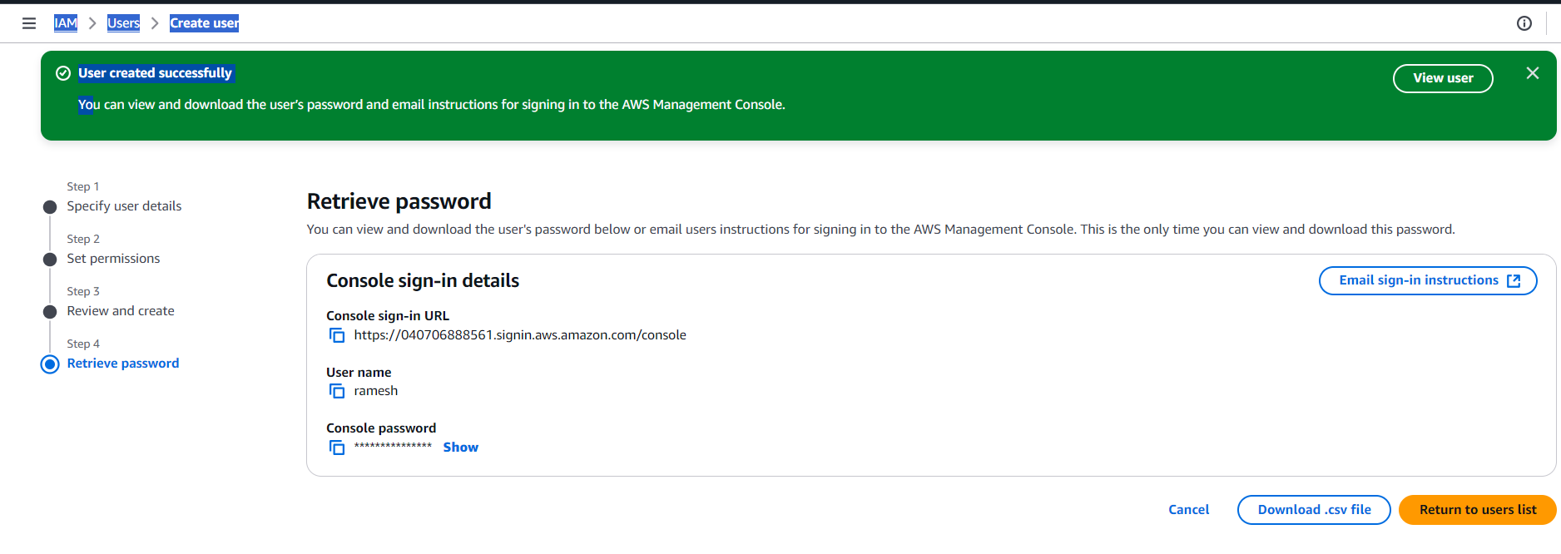

I have created a user name Ramesh and i have given permissions to it

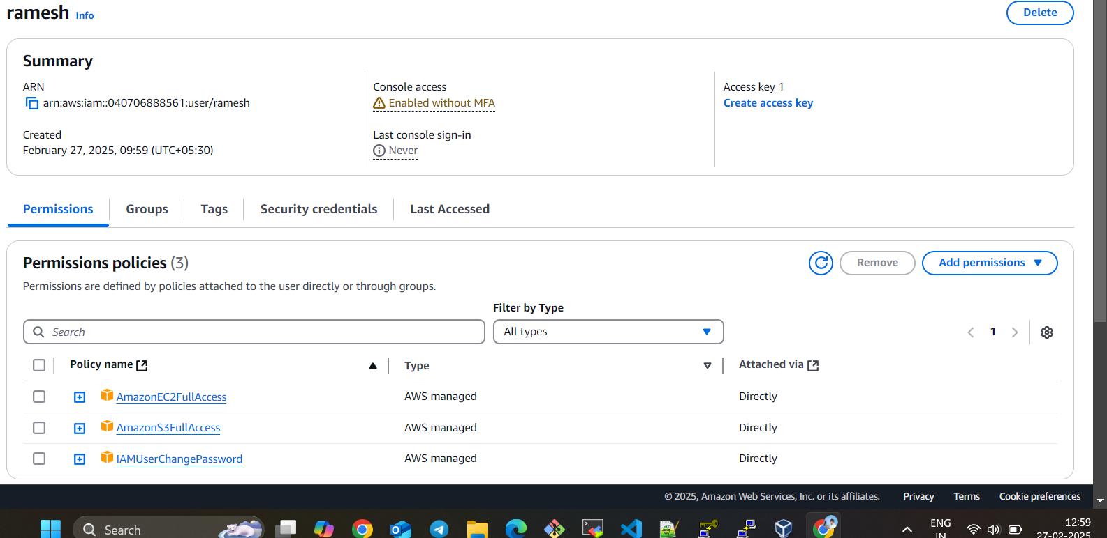

I have logged with my IAM user you ca see i have full permission to acces or create bucket

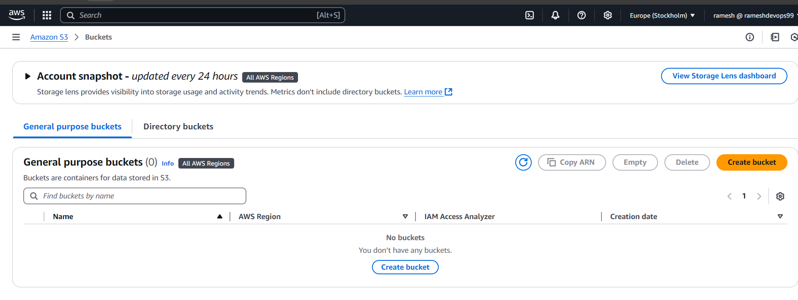

And also I have full access to my ec2

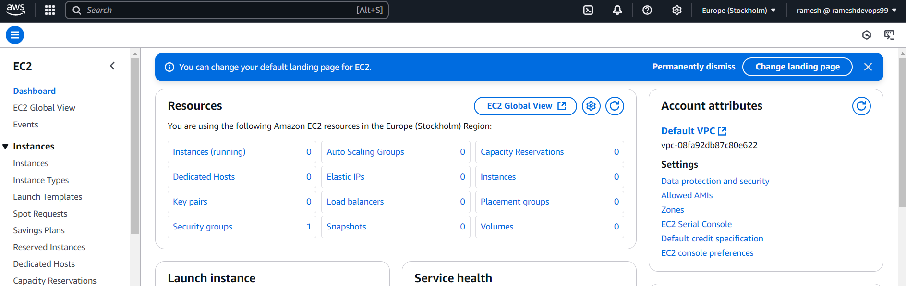

2) Create one Group in IAM and Assign Read access for ec2.

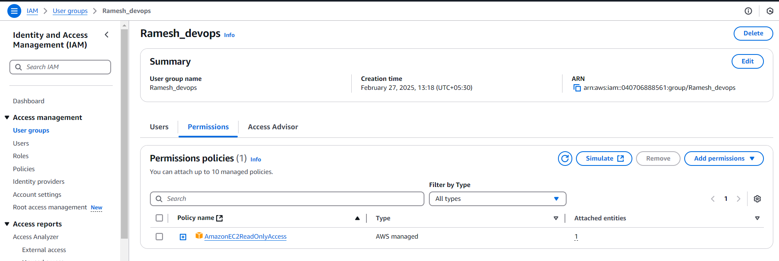

3) Create a new user with name Devops and add to the group created in task2.

You can i have given ec2 read only access so that’s the reason i am unable to launch instance

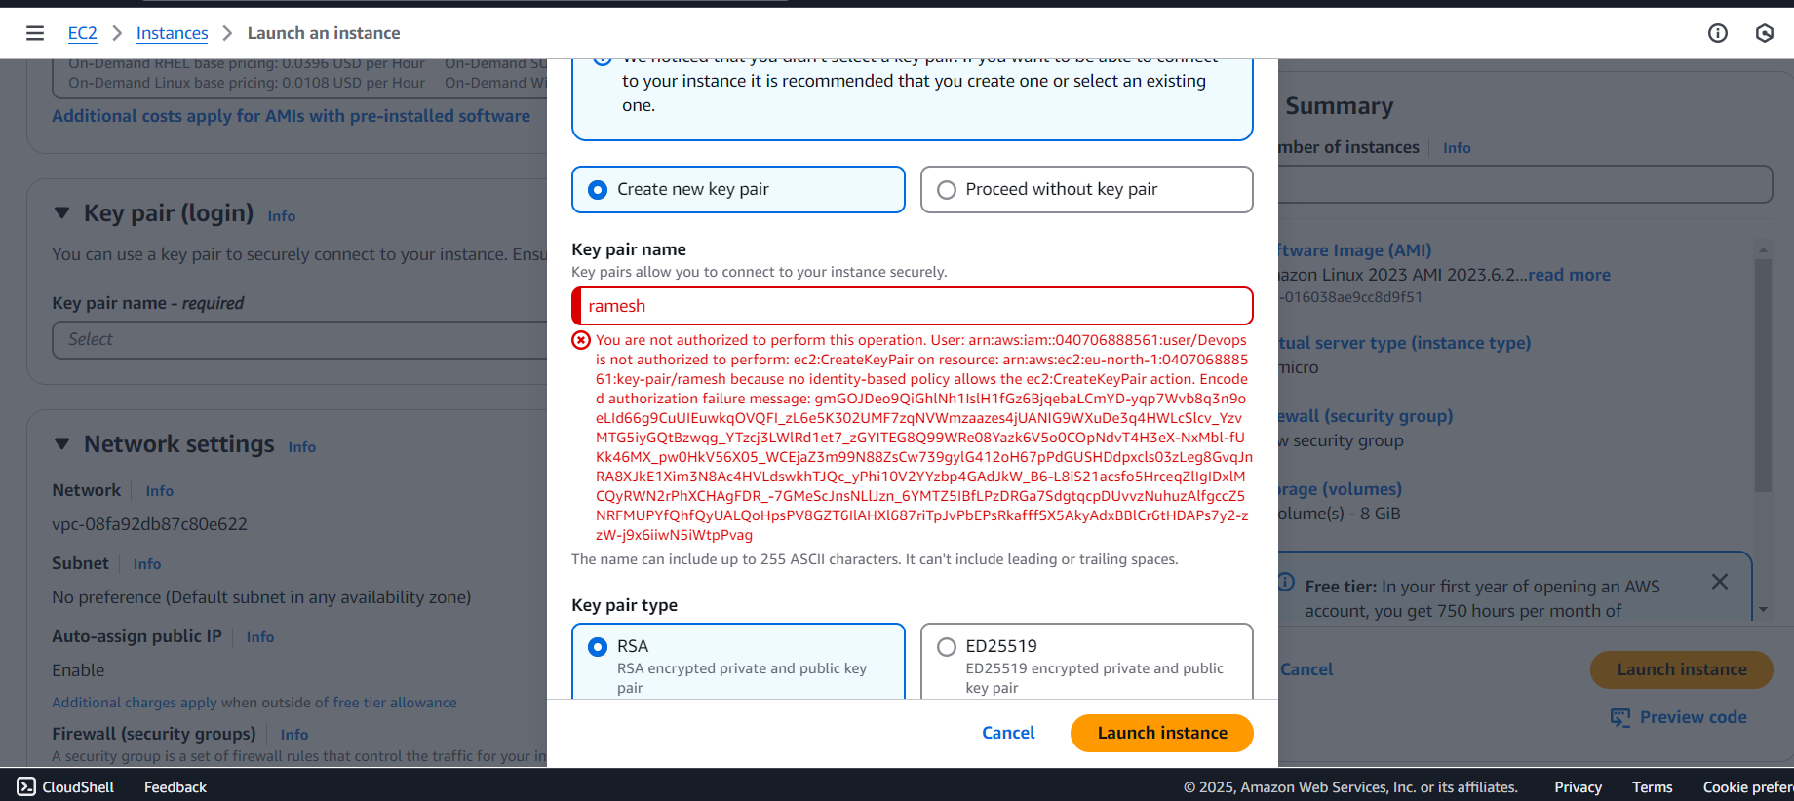

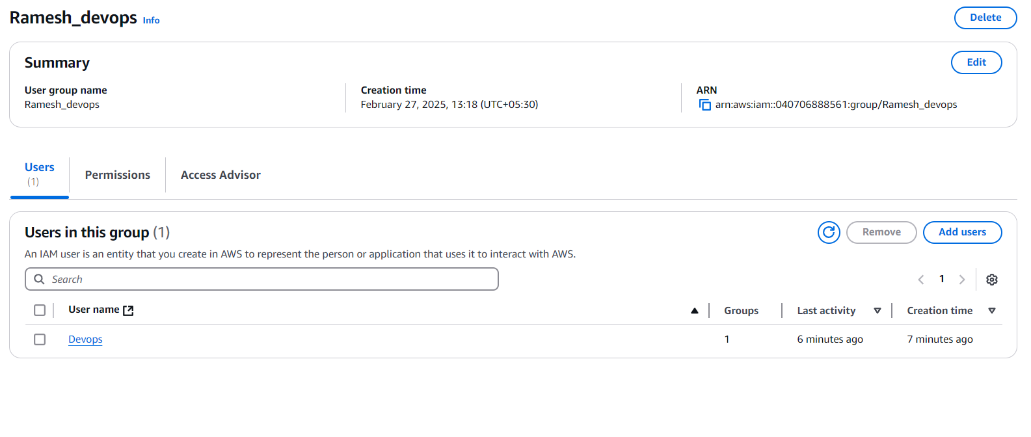

4) Write a bash script to create a IAM user with VPC full access.

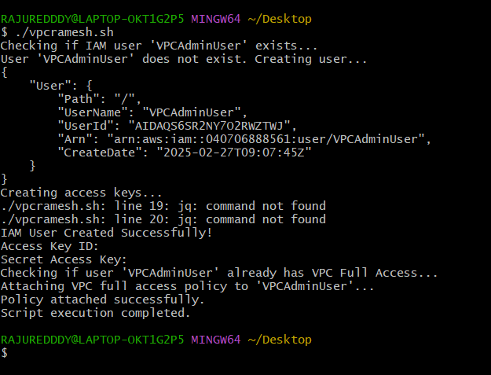

I have written a script to create a user with vpc access by using aws cli and check whether the user is already exists or not and also check the policy attached or not to that particular user

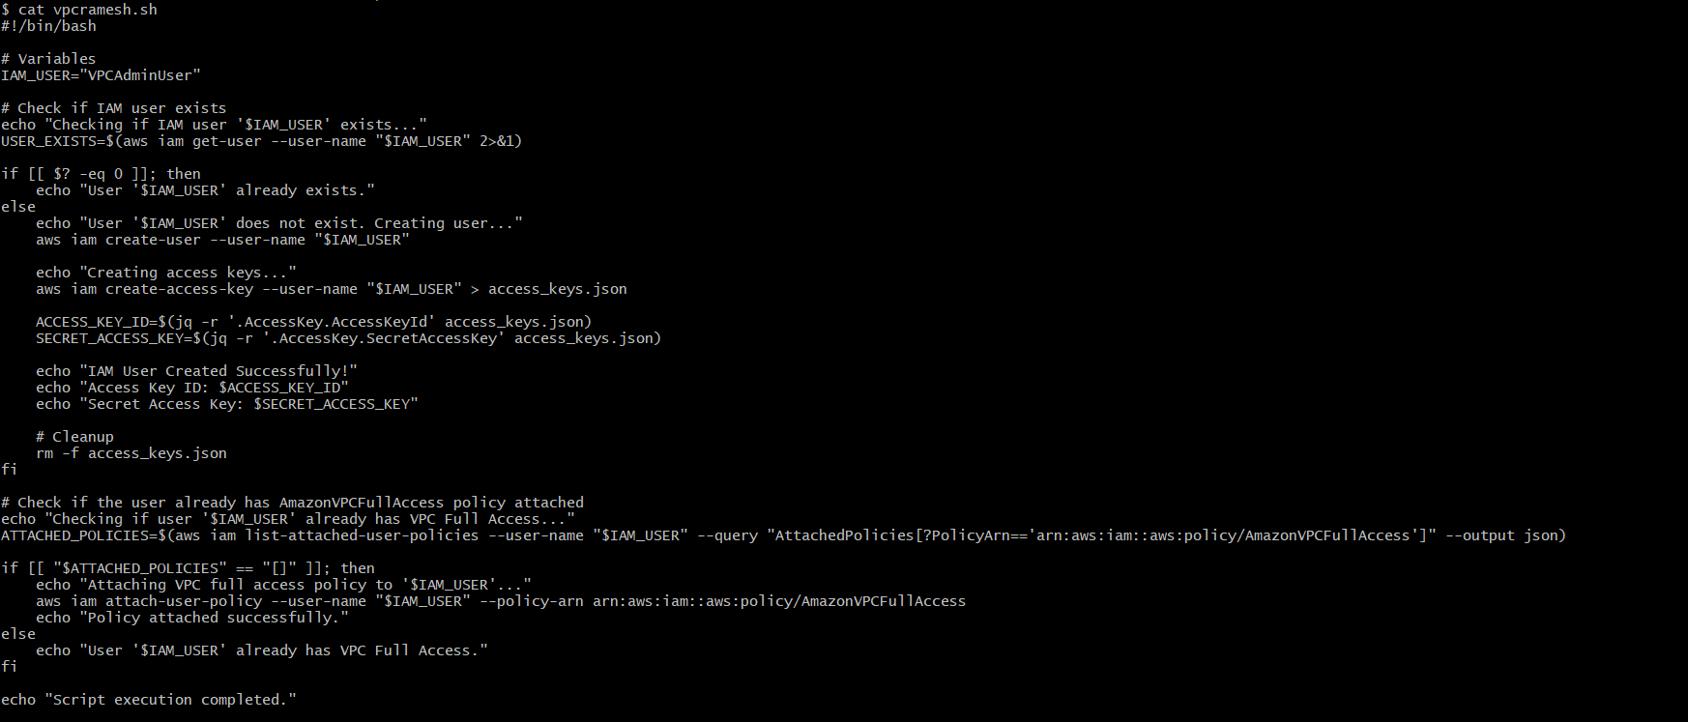

This is my GUI level in IAM i have created a user name VPCAdminUser using bash scripting

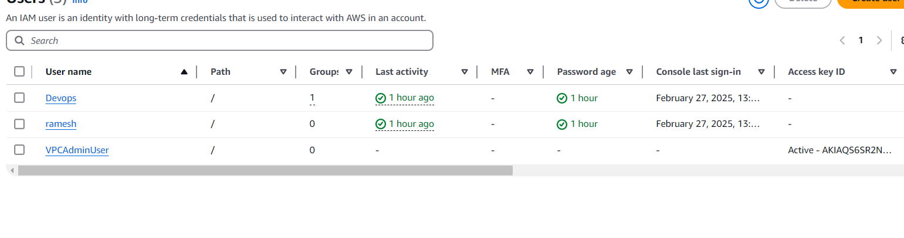

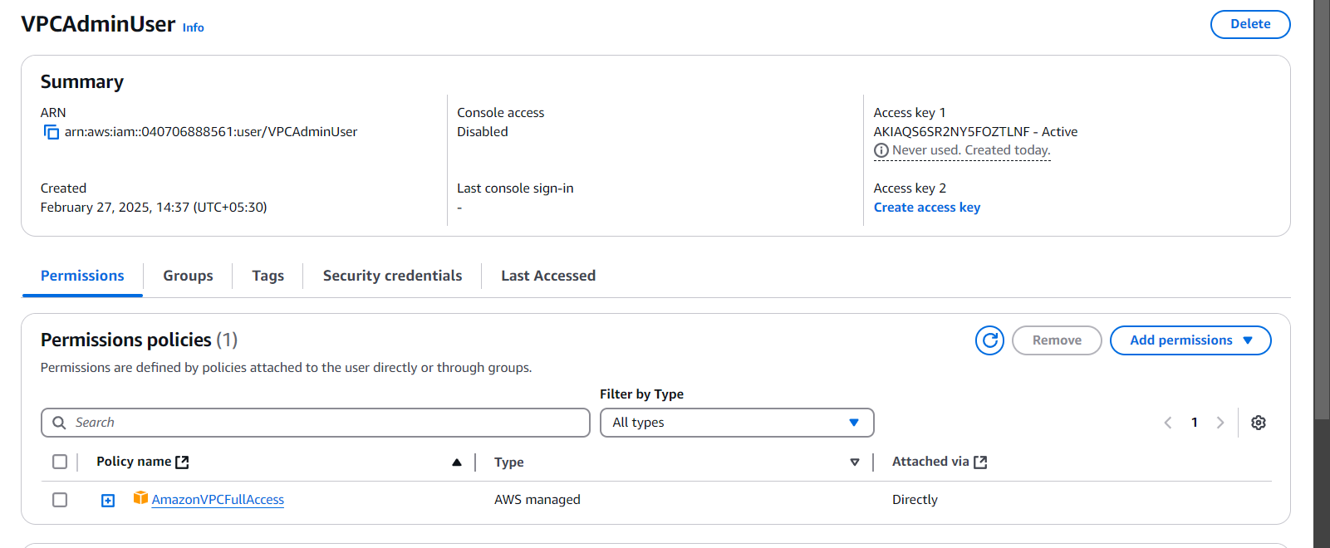

After login with IAM user my vpc console

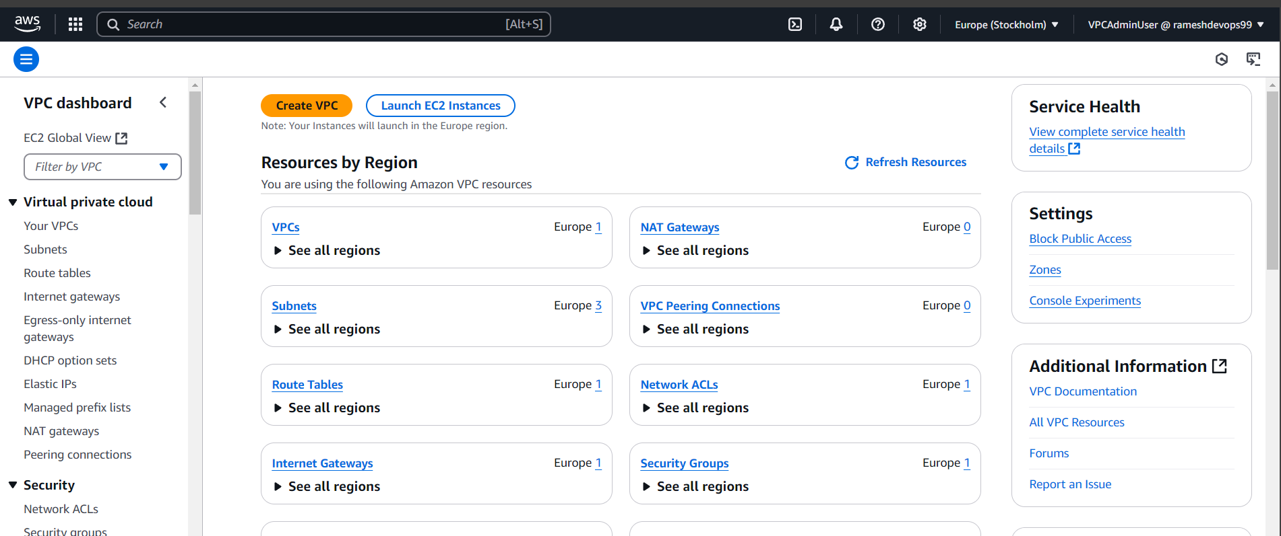

5) Create a IAM policy to access ec2 for a specific user in specific regions only.

I have created a policy by using Json

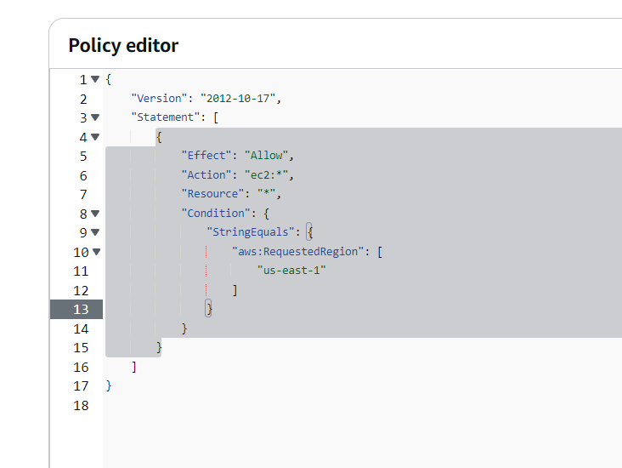

I have created a user anime raju attached that customer policy to my user

After login with my IAM user in different region in Ec2 the permission is denied

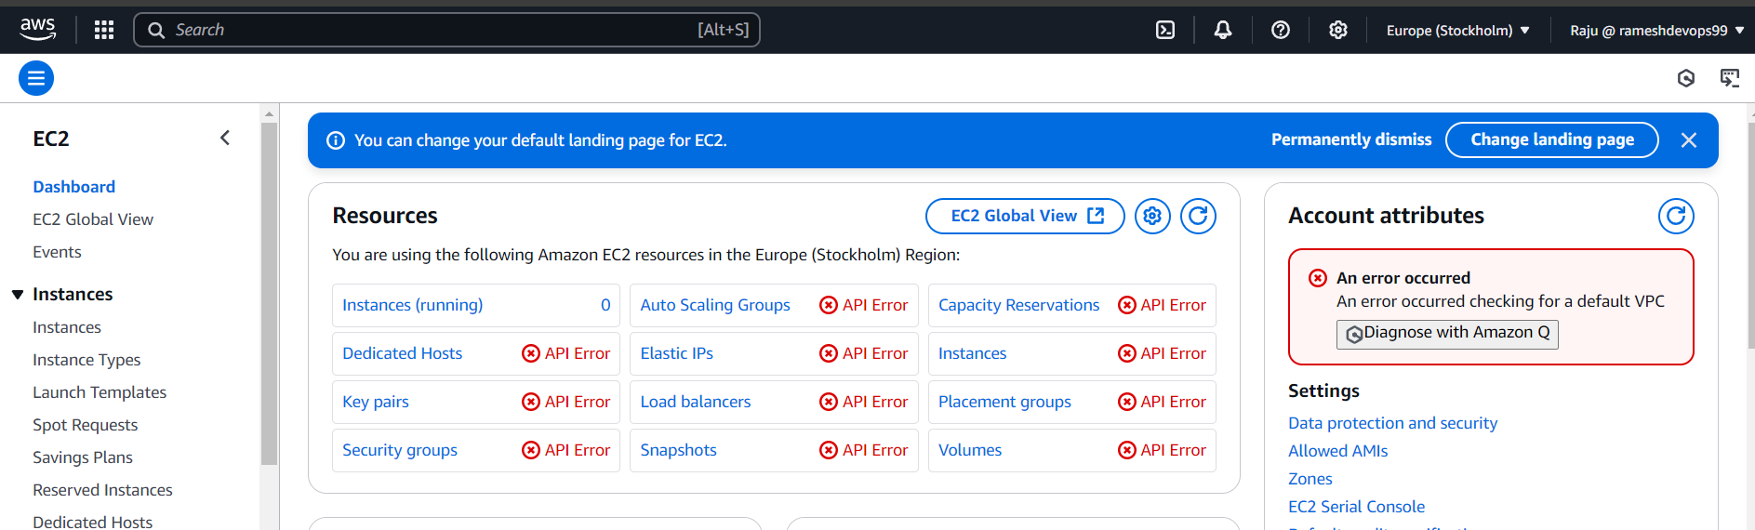

You can see my us-east -1 region where the user has full permission to ec2 user

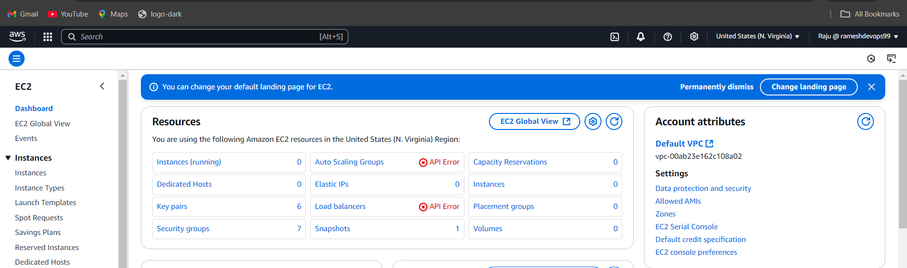

This is my IAM usert Raju you can see i haave given policy to ec2 one region only

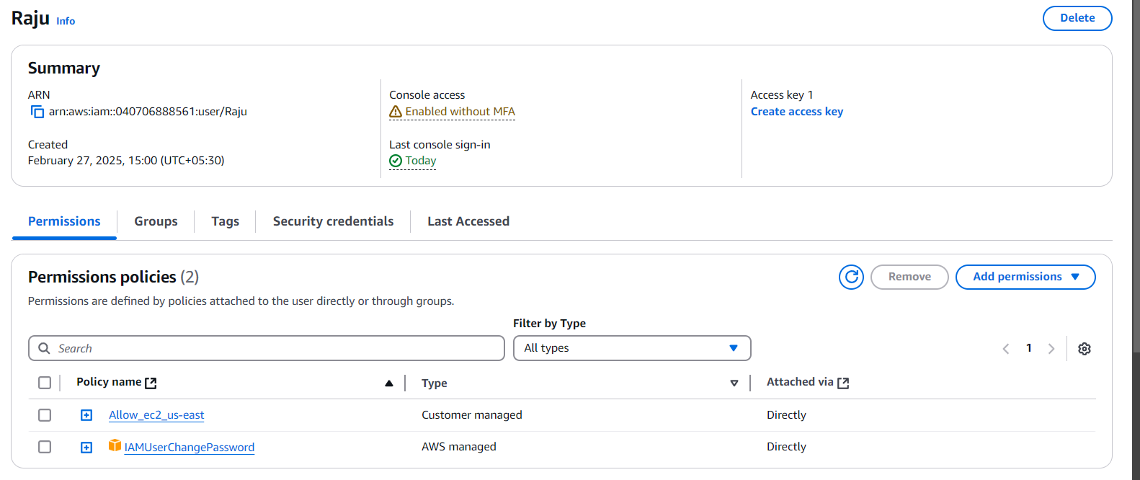

6) We have two accounts Account A and Account B, Account A user should access s3 bucket in Account B.

I am the account B

